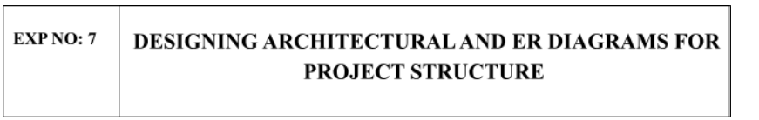
Aim:
To Design an Architectural Diagram and ER Diagram for the given Project.
7A. Architectural Diagram
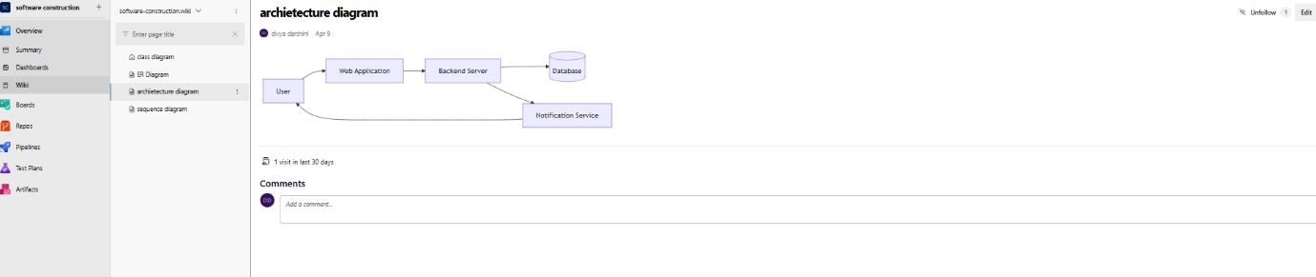
7B.ER Diagram
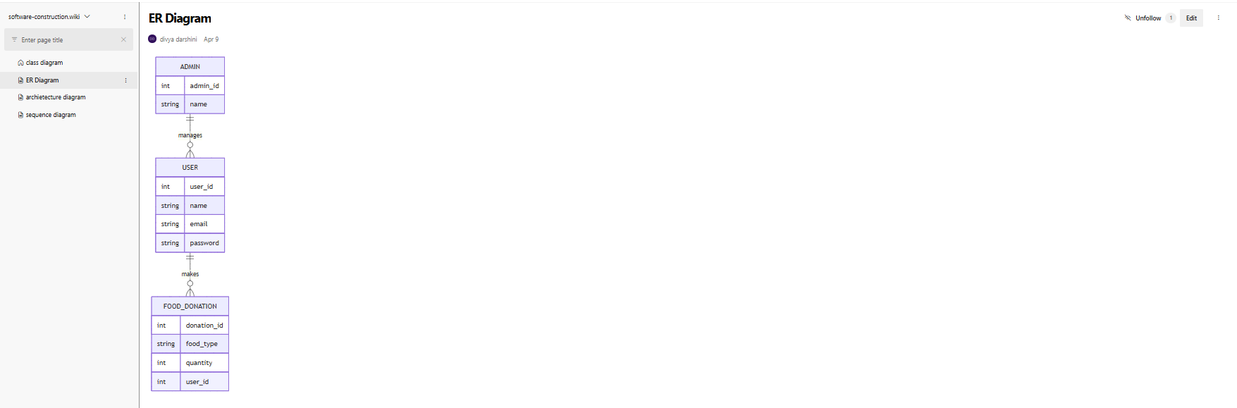

RESULT:
The Architecture Diagram and ER Diagram is designed Successfully for the Music Playlist Batch Creator

